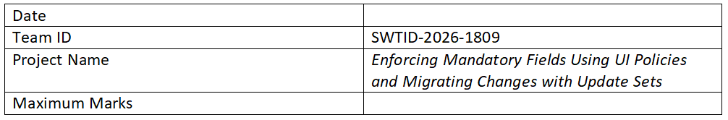
Project Title:
Enforcing Mandatory Fields Using UI Policies and Migrating Changes with Update Sets

1. Introduction
This project focuses on improving data quality and consistency by enforcing mandatory fields using UI Policies and migrating changes using Update Sets.

2. Objectives
- Ensure critical fields are not left empty
- Enhance UI dynamically
- Implement UI Policies
- Migrate configurations using Update Sets

3. Problem Statement
Users may skip important fields, leading to incomplete data. Also, changes must be migrated reliably.

4. Solution Overview
UI Policies enforce mandatory fields dynamically. Update Sets track and migrate changes.

5. Tools & Technologies
- ServiceNow Platform
- UI Policies
- Update Sets

6. Implementation
Create UI Policy -> Add UI Policy Action -> Test -> Create Update Set -> Capture changes -> Move Update Set

7. Results
Mandatory fields enforced and changes migrated successfully.

8. Benefits
Improved accuracy, reduced errors, better UX, smooth deployment.

9. Challenges
Correct conditions and update set conflicts.

10. Conclusion
UI Policies and Update Sets ensure data integrity and efficient migration.

